**Fanka Shundovska**

**IntelliJ – JAVA Homework 6**

1. Assign a method of String with a parameter name. Transfer the method to the main method and print it.

package com.edu.oop.domasnaJava6;  
  
public class myStringMethod {  
  
 public static void printName(String name) {  
 System.*out*.println("Hello, " + name + "!");  
 }  
}

package com.edu.oop.domasnaJava6;  
  
public class MyClassJava1 {  
 public static void main(String[] args) {  
  
 String myName = "Fani";  
 myStringMethod.*printName*(myName);  
  
 }  
}

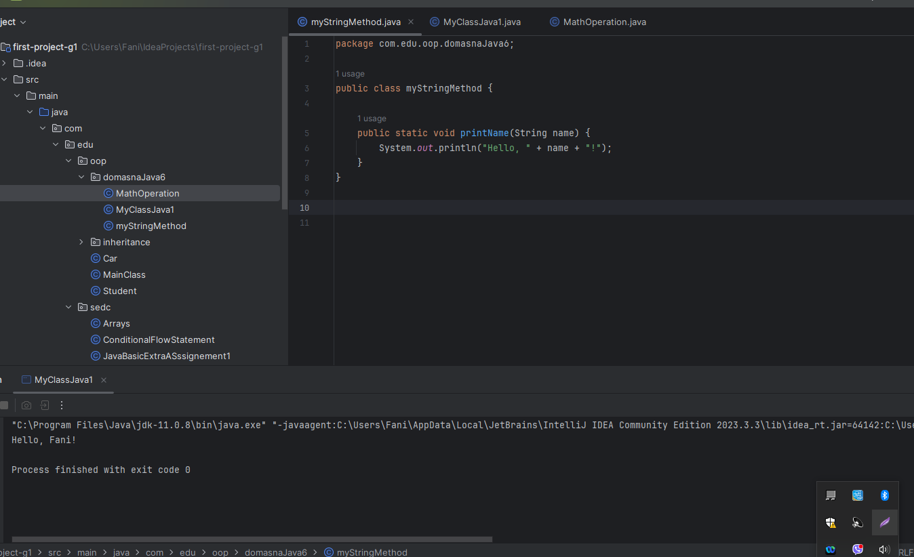

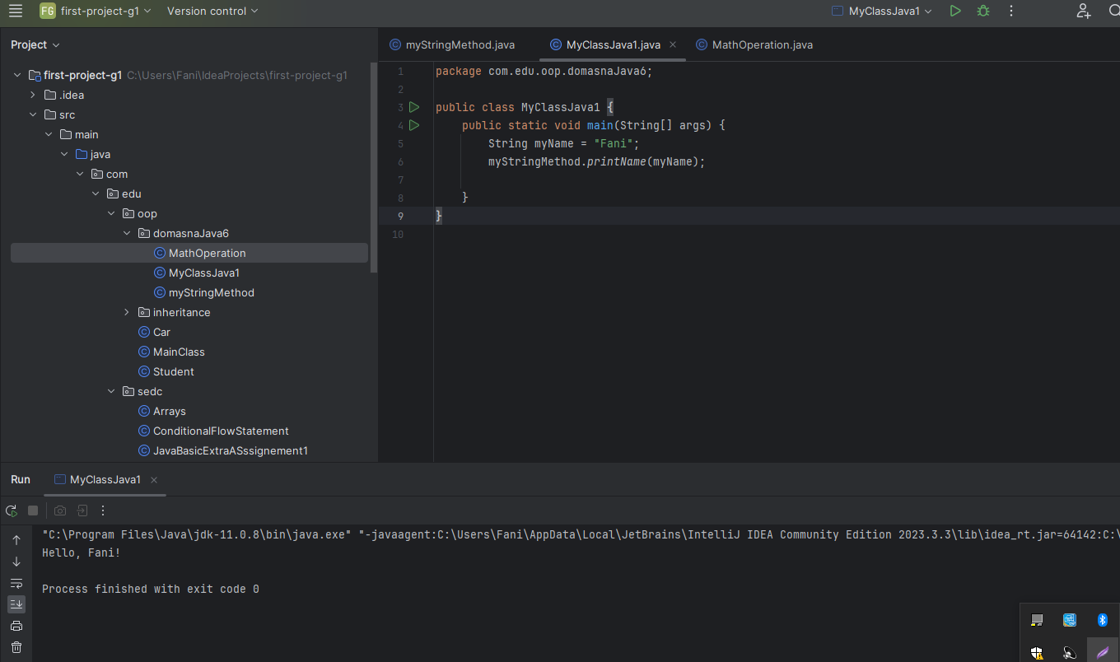

1. Assign one method of int and one double and give them parameters x, y and z.  Make a mathematical operation in the same of your own choice and print them in the main method.

package com.edu.oop.domasnaJava6;  
public class MathOperation {  
  
 public static double operation(int x, double y) {  
 double result = x * y;  
 return result;  
 }  
  
 public static void main(String[] args) {  
 int x = 5;  
 double y = 3.14;  
 double z = *operation*(x, y);  
  
 System.*out*.println("Result of the operation: " + z);  
  
 }  
}

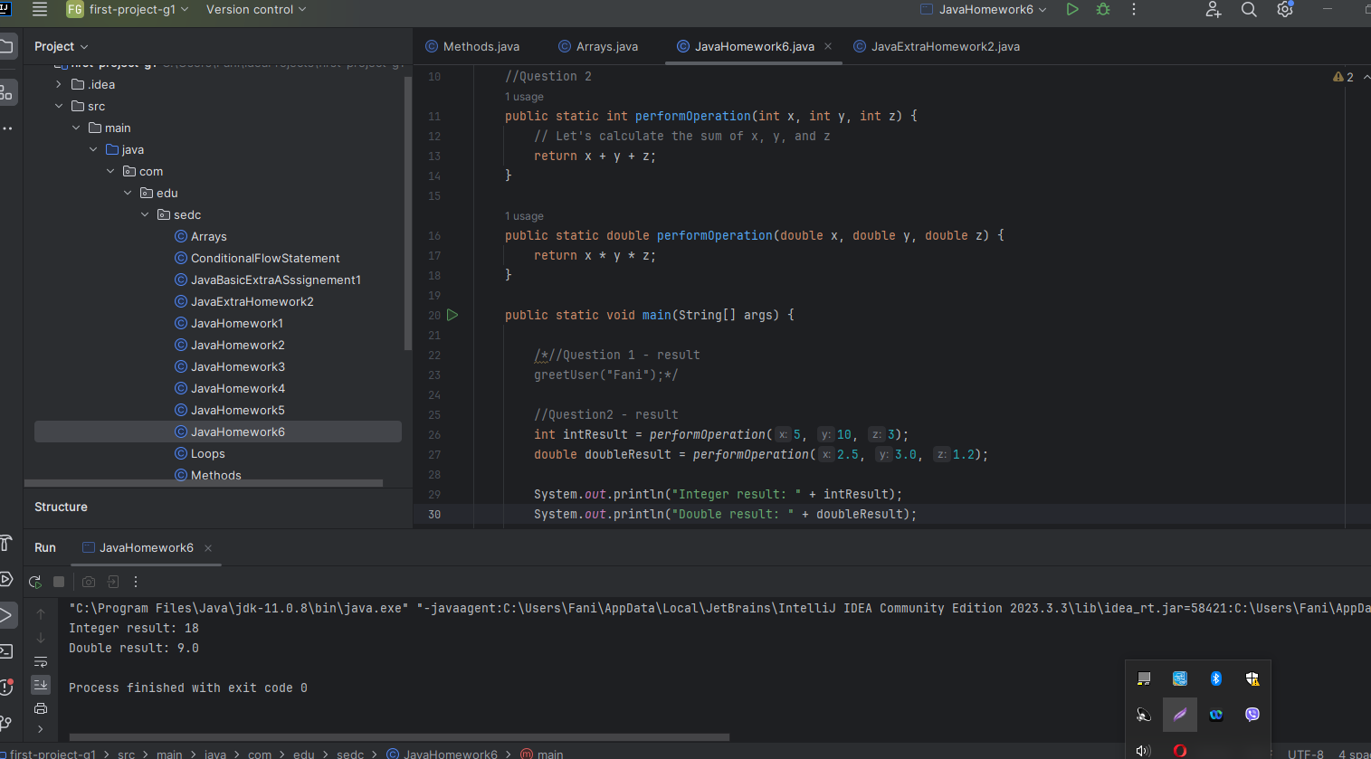

1. Make a double method containing an array and calculate the average value of the array. Print the result in the main method.

package com.edu.oop.domasnaJava6;  
  
public class Calculator {  
  
 public static void main(String[] args) {  
  
 double[] values = { 10.5, 20.0, 15.3, 8.7, 12.1 };  
  
 double average = *calcAverage*(values);  
  
 System.*out*.println("The average value is: " + average);  
 }  
  
 public static double calcAverage(double[] array) {  
 double sum = 0.0;  
 for (double value : array) {  
 sum += value;  
 }  
 return sum / array.length;  
 }  
}

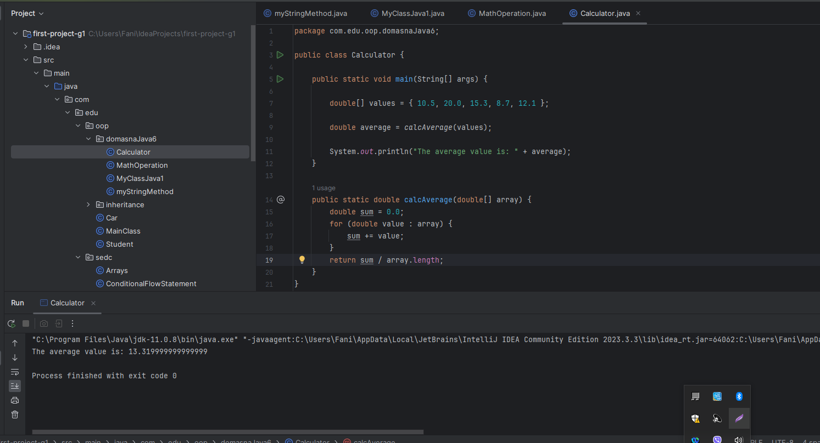

Second result:

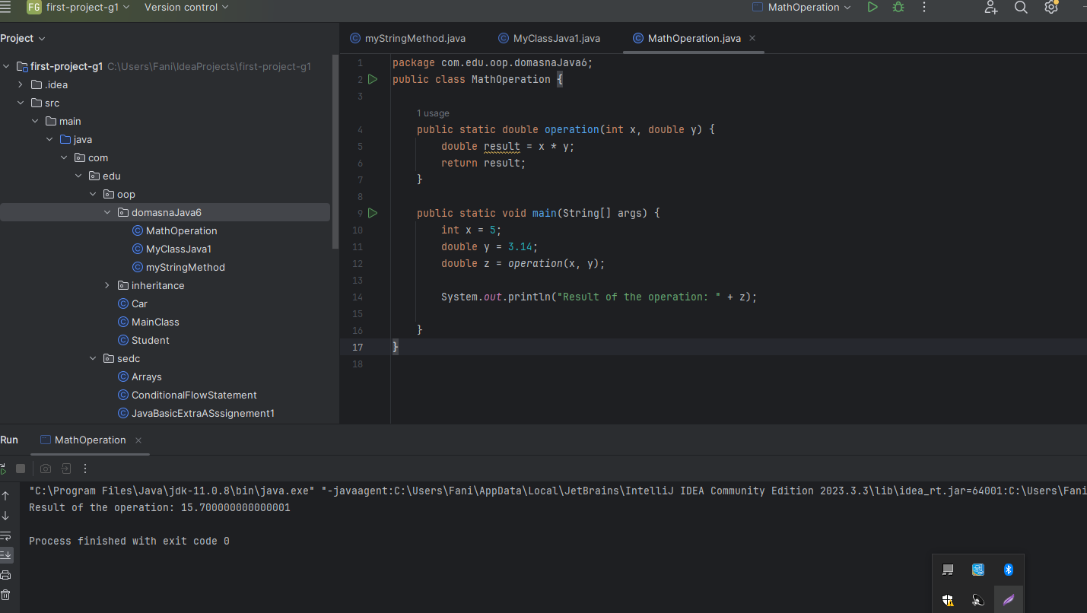

1. Write two methods. One that will return the odd numbers in the array, and the other one will return the even one.

public class OddEvenNumbers {  
  
 public static void main(String[] args) {  
  
 int[] numbers = {2, 4, 23, 100, 66, 11, 2602, 36};  
 int oddResult = *findOddNumber*(numbers);  
 int evenResult = *findEvenNumber*(numbers);  
  
 System.*out*.println("Odd number: " + oddResult);  
 System.*out*.println("Even number: " + evenResult);  
 }  
 public static int findOddNumber(int[] arr) {  
 for (int num : arr) {  
 if (num % 2 != 0) {  
 return num;  
 }  
 }  
 return -1;  
 }  
 public static int findEvenNumber(int[] arr) {  
 for (int num : arr) {  
 if (num % 2 == 0) {  
 return num;  
 }  
 }  
 return -1;

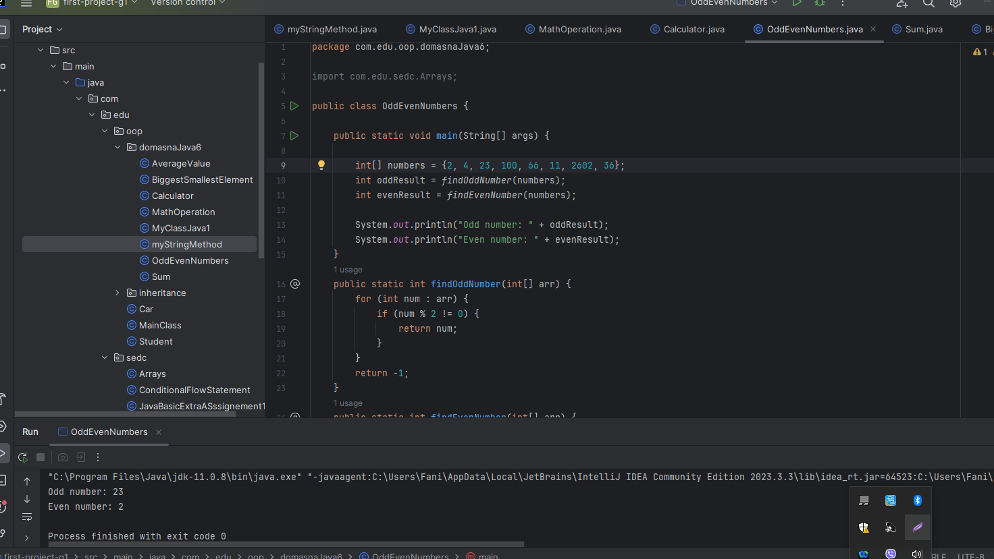

int[] numbers = {2, 4, 23, 100, 66, 11, 2602, 36};  
  
 for (int c = 0; c < numbers.length; c++) {  
 if (numbers[c] % 2 == 0) {  
 System.*out*.println(numbers[c] + " is even");  
 } else {  
 System.*out*.println(numbers[c] + " is odd");  
 }  
 }  
 }  
}

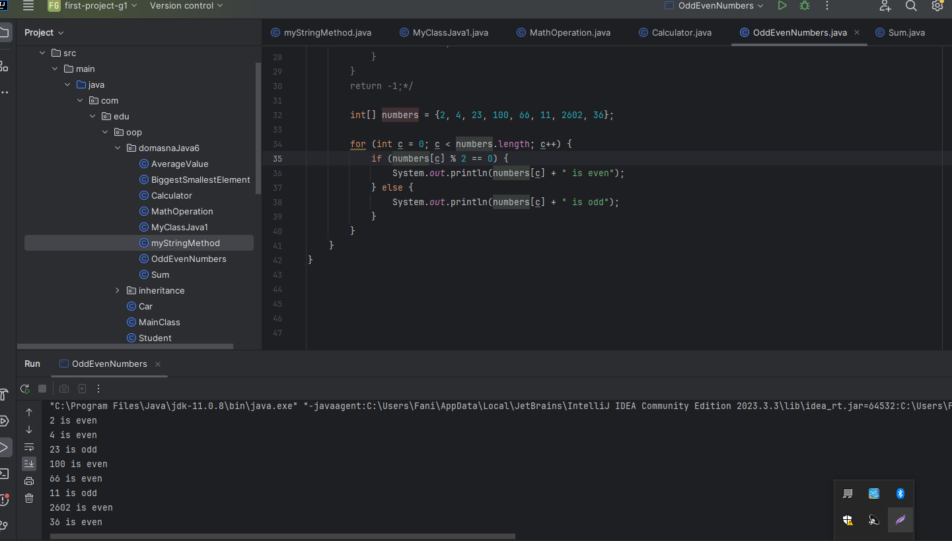

1. Write a method with 2 integer parameters and calculate the sum of the same. The main function of the method will be that if the sum of the parameters is bigger than 10 to print a message “Sum is bigger than 10” or “Sum is smaller than 10” . Additionally, if the sum is equal to 10, print ”Sum is equal to 10”.

public class Sum {  
  
 public static void main(String[] args) {  
  
 int num1 = 5;  
 int num2 = 7;  
  
 int sum = *calculateSum*(num1, num2);  
  
 if (sum > 10) {  
 System.*out*.println("Sum is bigger than 10");  
 } else if (sum < 10) {  
 System.*out*.println("Sum is smaller than 10");  
 } else {  
 System.*out*.println("Sum is equal to 10");  
 }  
 }  
  
 public static int calculateSum(int a, int b) {  
 return a + b;  
 }  
}

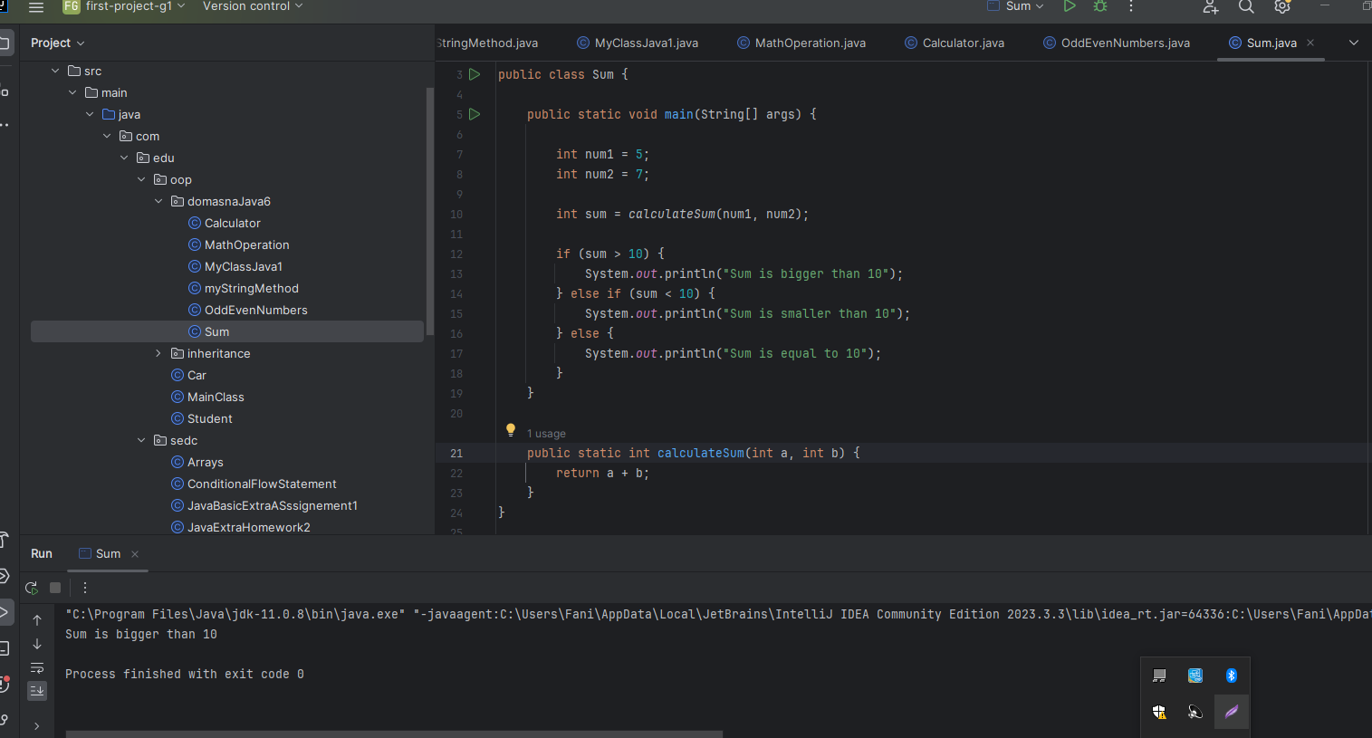

6. Write two methods (exercise from the presentation):

- One that will return the biggest element in a given array.

- And the other one that will return the smallest element in a given array

package com.edu.oop.domasnaJava6;  
  
public class BiggestSmallestElement {  
 public static void main(String[] args) {  
  
 int[] numbers = {2, 4, 23, 100, 66, 11, 2602, 36};  
 int largest = *findLargest*(numbers);  
 int smallest = *findSmallest*(numbers);  
  
 System.*out*.println("Largest element: " + largest);  
 System.*out*.println("Smallest element: " + smallest);  
 }  
 public static int findLargest(int[] arr) {  
 int largest = arr[0];  
 for (int num : arr) {  
 if (num > largest) {  
 largest = num;  
 }  
 }  
 return largest;  
 }  
 public static int findSmallest(int[] arr) {  
 int smallest = arr[0];  
 for (int num : arr) {  
 if (num < smallest) {  
 smallest = num;  
 }  
 }  
 return smallest;  
 }  
}

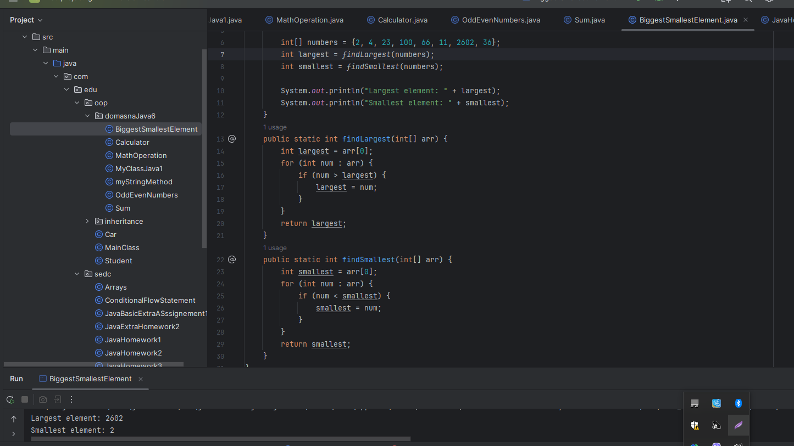

7. Write a method to calculate the average value of 3 numbers.

package com.edu.oop.domasnaJava6;  
  
public class AverageValue {  
 public static void main(String[] args) {  
  
 double num1 = 5.0;  
 double num2 = 7.0;  
 double num3 = 9.0;  
  
 double average = *calculateAverage*(num1, num2, num3);  
  
 System.*out*.println("Average value: " + average);  
 }  
 public static double calculateAverage(double a, double b, double c) {  
 return (a + b + c) / 3.0;  
  
 }  
}

